
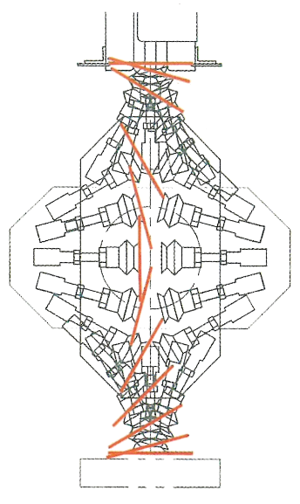
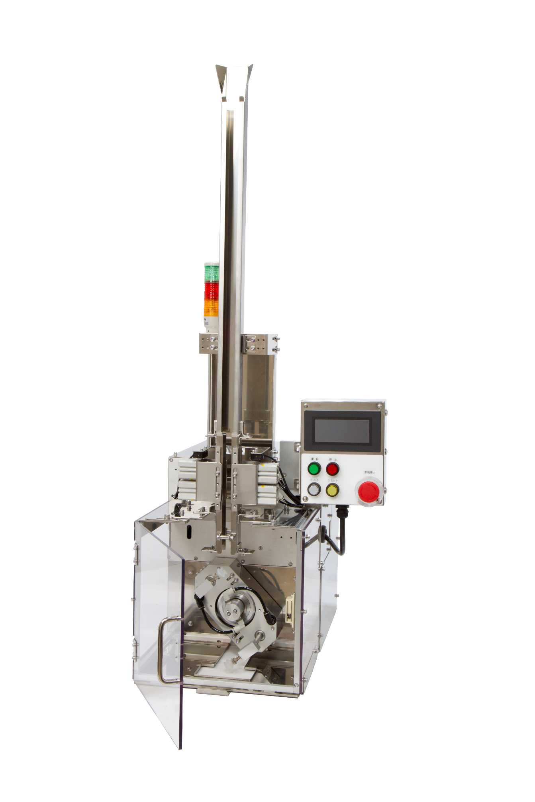
Easy to use with new Touch Panel
240pcs/min Capacity with
Rotary Mechanism
For the following items
- Collector’s cards/Novelty cards
- Promotional stickers
- ’AGELESS’ cards
- Desiccant sheet
MODEL
Card Distributor

High-Speed

CT-24T
ASAHI KINZOKU Co.,Ltd
The pioneer of loading machine.

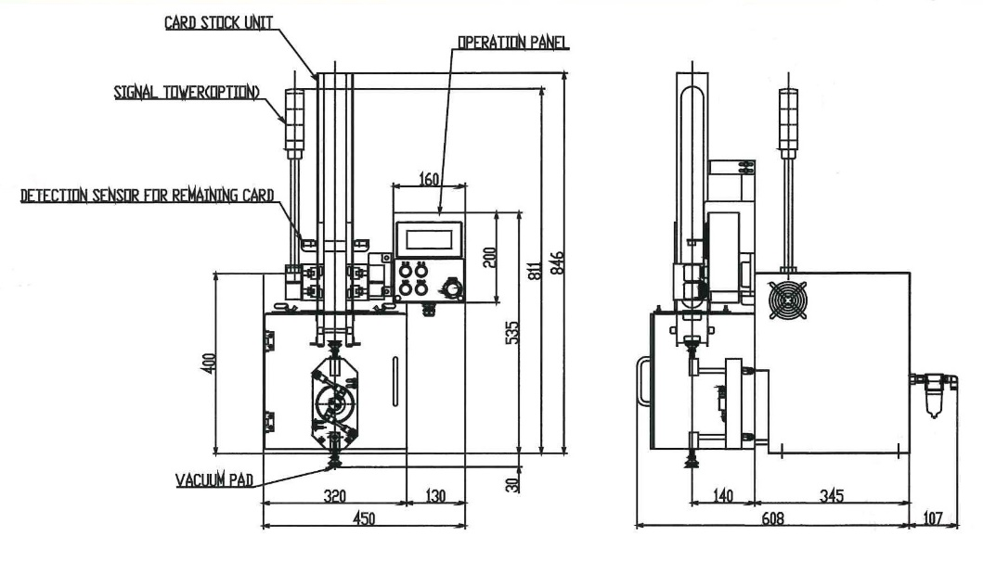

240pcs/min
450mm(W)×608mm(D)×535mm(H)
35kg
AC 200V 50/60Hz Single phase
1KVA
0.5~0.6MPa
100Nℓ/min
30~100mm (W)×30~100mm(L)×MAX1mm(T)
Capacity:
Dimensions:
Weight:
Power Supply:
Power Consumption:
Air Pressure:
Air Consumption:
Card Size:
HIGH-SPEED CARD DISTRIBUTOR is ideal for placing ‘AGELESS’ cards, stickers, desiccant sheet, and more on to the conveyor of a packaging machine.
- Compact design, due to the rotary mechanism, permits smooth distributing with
high-speed operation.
- High stability for safe operation.
- Easy to change cards with a cassette type feeder.

CAUTION
For Safe Use
●Read operation manual carefully before use for proper and correct operation
●Use the machine only with indicated electric
current and voltage
●Be sure to ground the machine to prevent electrocution or short circuit.

- We have extensive experienced
in card distributing.
Please do not hesitate to
contact us for more information.
- Specifications and appearance
are subject to change without
notice for improvement.
●Signal Tower ●Adjustable Stand
●Conveyor for each packaging machine.
505 Simomaruya-cho, Nishi-iru, Chiekoin-dori,
Shimodachiuri-dori, Kamigyo-ku, Kyoto city
602‐8176 JAPAN
Tel ＋81-75-801-0154 Fax ＋81-75-842-1351
URL http://www.akg.jp/kinzoku/
E-mail asahi@akg.jp

10-2 Miyamoto-cho, Ageo city, Saitama Prefecture
362-0036 JAPAN
Tel ＋81-48-771-0662 Fax ＋81-48-773-5937

No．206 Ichikura Building, 1-26, 2-chome, Hakata station south, Hakata-ku, Fukuoka city
812-0016, JAPAN
Tel ＋81-92-471-5234 Fax ＋81-92-473-7150

Sep.6.2021
- Reference

SCHEMATIC
DIAGRAM

STANDARD
SPECIFICATIONS

OPTIONAL DEVICES
ARE AVAILABLE

Sales&
Manufacturing
Headquarters

Tokyo Sales Office

Kyushu Sales Office
CT-24T
features

